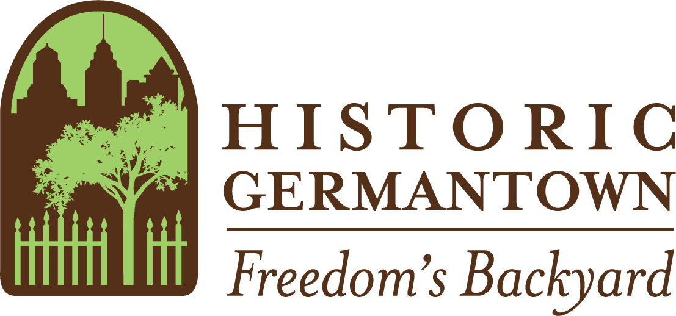
MEMBERSHIP

Annual Membership Levels
󠄁 General: Student ($20), Individual ($35), or Household ($50): Unlimited free visits and two guest passes to the Germantown Historical Society museum, library and archives, Subscription to the Germantown Crier, Monthly e-newsletter Advance notice of special events, exhibitions, and programs Individual passport to all Historic Germantown sites for one year
󠄁 History Hunter: ($100 - $249): General benefits PLUS $15 gift certificate for our bookshop
󠄁 The Concord Club: ($250-$499): History Hunter benefits Complimentary admission to lectures and programs, Opportunity to join us for activities planned exclusively for Club members
󠄁 The Heritage Circle: ($500-$999) Concord Club benefits PLUS Private "behind the scenes" tour of the Germantown Historical Society, Complimentary 2-hour use of GHS facilities
󠄁 The Preservationist Guild: ($1,000+) Heritage Circle benefits PLUS Annual Preservationist Guild reception at a Historic Germantown site or private home featuring a talk by a leading collector, historian or artist.
Please charge my donation to my 󠄁󠄁 Visa 󠄁󠄁 Mastercard 󠄁󠄁 Discover
Card Number_________________________________Exp. Date_______CVV______
Signature__________________________________________________
Charge Amount $_______________
Your name as you would like it to appear in our records:
NAME Dr./Mr./Mrs./Ms.______________________________________________
ADDRESS_________________________________________________________
CITY________________________________ STATE____ ZIP CODE____________
PHONE_________________________ E-MAIL____________________________
The official registration and financial information of Historic Germantown may be obtained from the Pennsylvania Department of State by calling toll free within Pennsylvania, 1-800-732-0999. Registration does not imply endorsement.
All gifts are tax-deductible to the fullest extent allowed by law.
Thank you for your support!

